Collection And Generics:
Int a[]=new int[4];// Drawback: Array size is fixed
If Elements numbers are fixed always go for Arrays since array is fast compare to Collection.
Questions:

- Data-Provider
Working with POI:
File Input Stream àWorkBook à Sheet [Get All Details]àRowàCell
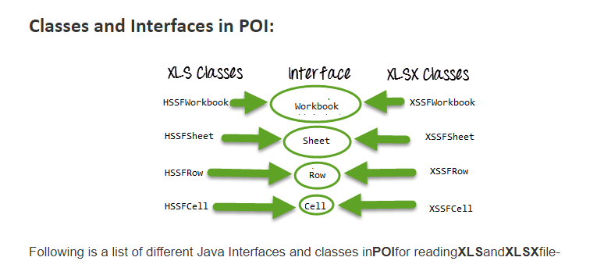

- Workbook: XSSFWorkbook and HSSFWorkbook classes implement this interface.
- XSSFWorkbook: Is a class representation of XLSX file.
- HSSFWorkbook: Is a class representation of XLS file.
- Sheet: XSSFSheet and HSSFSheet classes implement this interface.
- XSSFSheet: Is a class representing a sheet in an XLSX file.
- HSSFSheet: Is a class representing a sheet in an XLS file.
- Row: XSSFRow and HSSFRow classes implement this interface.
- XSSFRow: Is a class representing a row in the sheet of XLSX file.
- HSSFRow: Is a class representing a row in the sheet of XLS file.
- Cell: XSSFCell and HSSFCell classes implement this interface.
- XSSFCell: Is a class representing a cell in a row of XLSX file.
- HSSFCell: Is a class representing a cell in a row of XLS file.

FileInputStream fileInputStream= new FileInputStream(" ");
Workbook wb=new XSSFWorkbook(fileInputStream);
Sheet sheet=wb.getSheet("CloudLoginCredentials");
Row row=sheet.getRow(2);
String name=row.getCell(1).getStringCellValue();
System.out.println("name:"+name);

Q1: Put some condition to print "ifelse"
if(condition){
sysout("if");
}else{
sysout("else");
}
Q2: What is set in java
Q3: How HashSet is implemented in java
Q4: Write a program to print 1 when i pass 0 and 0 when i pass
1(Without using if else and Switch statements)
Q5: What are DLL files
Q6: Write a program to print values from an array which are neither min nor max
Q7: What will happen when i will create two classes in the same java file
Q8: How many class files will be created in case of nested classes
Ans: 2 One named as OuterClass.class and other will be
OuterClass$InnerClass.class
> Logic to update the content in the even no. of rows of a table
> What is threading and how it can be implemented
> Opps concepts
> Difference between abstract classes and interfaces
> Difference between hashmap and hashtable
> what is hashset
> what is synchronization and give a real-time example of it
> Roles in Agile
> What is the role of scrum master in Agile
> Login page implementation in cucumber
> Keywords of cucumber
> Annotations of cucmber
> How to define runner class in cucumber (Code Implementation)
> Is it possible to use @Cucumber.Options instead of @CucumberOptions
> Which reporting tool you are using with cucumber

Recursion

